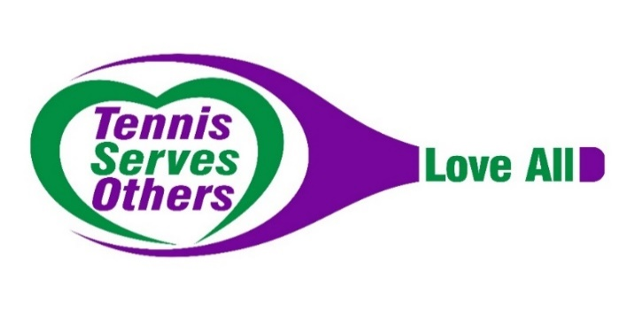
Dear Friend & Supporter:

On behalf of Tennis Serves Others, a 501c3 non-profit organization, and Laguna Niguel Racquet Club, we invite you to support our 5th Annual TSO WIMBLEDON Grand Tournament & Gala to be held on Saturday, June 26th.

Founded in 2016, Tennis Serves Others has served more than fifty different charitable groups providing supplies and over $200,000 in financial assistance to thousands of people in California, Mexico and Africa through our fundraising events. Our Tennis SOLES for Others, Tennis SUPPLIES Others, and our TSO Give Back program allow us to support the homeless, families in poverty, orphans around the world and youth tennis in our local communities. We are sincerely grateful to have such support of our members who volunteer countless hours, of Laguna Niguel Racquet Club, and of our community.

This year, our members voted to support two organizations…Forever With Us and Fristers!

Forever With Us aids families in Orange County who have recently lost a child to cancer by working with local children’s hospitals and social workers. Forever With Us strives to alleviate the financial burden and stress of funeral costs after losing a child to cancer. One in 5 children diagnosed with cancer will not survive. Forever With Us provides funds for a celebration of life and continues to help grieving families by connecting them with support groups and providing holiday gifts.

Fristers serves pregnant teens in Orange County by offering educational, vocational, relationship and parenting training. Fristers teaches young parents how to thrive and build healthy and stable families. Fristers is the only program in Orange County to provide a full suite of services and programs for young moms, dads, couples and children.

Through your support of Tennis Serves Others, you can make a difference. We invite you to support us in these ways:
- Donate an item or service for our silent and/or live auction;
- Direct Sponsorship Support – Cash donations, sponsorship levels, or assisting with offsetting costs of player bags, food, alcohol, entertainment, etc;

We need your support. Will you help? With your tax-deductible donation, we can use tennis to serve others and provide hope to many. Enclosed please find a pledge form to return with your donation. All donations are appreciated and will be acknowledged at our Grand Tournament and Gala.

Together, we can make a difference. Thank you for your support.

Love All,
Kelley McBride, CEO Carol Walsh, Founder & Chairperson
Kelly Kehlet, Events Chair Amy Berk, Treasurer
Roya Khairzada, VP Fundraising Jenny Thurrell, VP Fundraising
Julia Keene, VP Marketing
www.tennisservesothers.org
Tax ID #81-1801864

Tennis Serves Others
Grand Championship Gala & Tournament
June 26, 2021

Donor Name: _____________________________________________________________
Address: _________________________________________________________________
City/State/Zip:____________________________________________________________
Cell phone (_____)_____________________ E-mail: _____________________________

We would like to donate an item or service for the auction:
Description of
Donation/Gift:______________________________________________________________________________________________________________________________________________________________________________________________________________
Value: $______________

I WOULD LIKE TO SPONSOR THE TSO WIMBLEDON GRAND GALA & TOURNAMENT AT THE FOLLOWING LEVEL:

____ $5000 Title Sponsor ____$2500 Grand Champion

____ $1000 Finalist Sponsor ____$500 Semi-Finalist Sponsor

____ $250 Quarter Finalist Sponsor ____$100 Spectator

Please accept a donation in the amount of $____________

Love All!
If you have an item for pick-up, or would like to discuss sponsorship options, please:
email tennisservesothers@gmail.com and we will contact you.

Tennis Serves Others – PO Box 1084, San Juan Capistrano, 92693
Tennis Serves Others is a 501c3 registered tax-exempt non-profit organization, tax ID number is 81-1801864.
Tennis Serves Others’ mission is to unite ladies in the tennis community to organize and promote charitable activities benefiting needy individuals, groups or other organizations in our local communities and throughout the world.

